Comprehensive Care Clinics
The Bleeding & Clotting Disorders Institute’s mission is to provide integrated, family-oriented care, treatment and education for persons with bleeding, clotting and other blood disorders. BCDI is a non-profit, federally funded Hemophilia Treatment Center (HTC) and is the only federally funded HTC in Illinois outside of Chicago. At BCDI, our team of hematologists, advanced practice providers, nurses and other specialists are highly trained in treating patients of all ages with a variety of bleeding and clotting disorders and other blood disorders. Our multidisciplinary team provides treatment and support for the whole patient as well as his or her family. BCDI offers uniquely designed Comprehensive Care Clinics as a way to provide the best care for our patients with bleeding and clotting disorders.
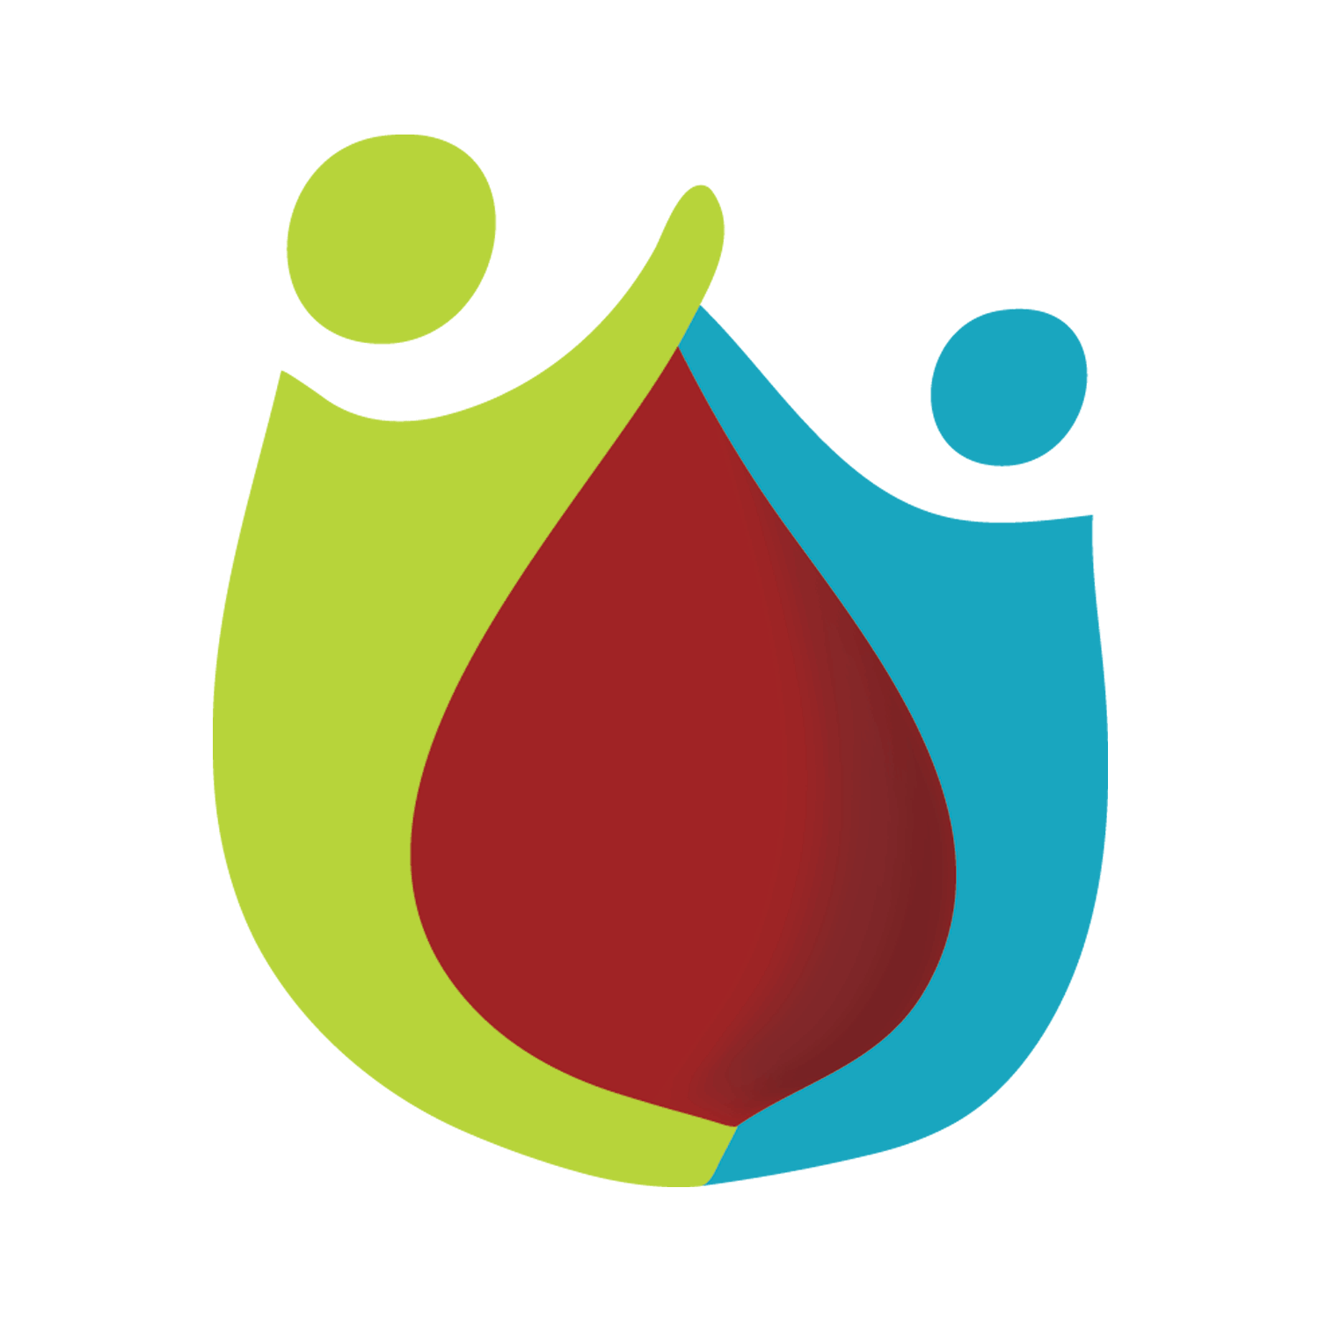
What is a Comprehensive Care Clinic?
- A Comprehensive Care Clinic (comp clinic) is a clinic that is specially designed to meet the specific needs of a diagnosis and provide the patient with the best care possible. At a comprehensive care clinic, the patient will see a variety of providers and specialists that work together to provide complete, comprehensive care. Members of the multidisciplinary care team include:
- BCDI Hematologist – Doctor who specializes in blood disorders.
- BCDI Advanced Practice Provider– Nurse Practitioner or Physician Assistant who specializes in blood disorders.
- BCDI Nurse Coordinator – Specialty trained nurse involved in the care of the patient and knowledgeable in blood disorders.
- BCDI Physical Therapist – Physical Therapist who specializes in activity, exercise and rehabilitation for patients with bleeding and clotting disorders.
- BCDI Medical Social Worker – Social worker specializing in navigating care for patients with bleeding and clotting disorders. Assists with issues of daily living (both physical and emotional), helps with locating resources and coordination with schools.
- BCDI Pharmacy Team – Pharmacists and pharmacy technicians knowledgeable in commonly prescribed medications for bleeding and clotting disorders. Includes on-site pharmacy for filling medications.
- BCDI Research Team – Department committed to ongoing research in areas of bleeding and clotting disorders and data collection.
- BCDI Laboratory – Specially trained in blood draws and performing specialty lab tests in on-site laboratory.
- Dentist - Specialist in disorders of the teeth and gums and experts in treating children and adults with oral bleeding problems.
- Immunologist – Doctor specializing in the immune system and how it interacts with specific conditions and diseases.
- Nutritionist – Knowledgeable in how diet interacts with specific diagnoses and medications related to those diagnoses.
*The care team present at each comp clinic will vary. The multidisciplinary team is specifically chosen for each comp clinic based on the patients seen in that clinic and their diagnoses. This results in individualized, patient centered care.*
Am I Charged Extra for a Comp Clinic Visit?
- No, a comp clinic is billed the same as a “regular” clinic visit. The additional care provided by members of the multidisciplinary team at a comp clinic is available to you because we recognize the importance in providing quality, complete care.
How Long Does a Comp Clinic Appointment Last?
- Because you can be seen by additional providers and specialists, a comp clinic visit is longer than a “regular” clinic visit. The length of the visit will depend on how many additional specialists are seen as well as the needs of the patient; this is because we want to ensure each patient’s needs are met. These visits can last anywhere from an hour to two hours or more. We ask that you plan accordingly, and we encourage you to bring refreshments with you as well as packing any supplies needed for your children if they are present during your visit. We do have toys, books and TVs available to help keep children entertained.
What Should I Bring to My Comp Clinic Appointment?
- Bring a list of all medications you are currently taking. This list should include any prescription medications, over-the-counter medications, and any vitamins, herbs or supplements you are taking.
- Come with any questions you have for your doctor or other members of the team.
- Be ready to discuss any recent changes to your health or any upcoming procedures, surgeries or dental work.
- If applicable, bring your infusion log and bleed log. This is helpful information for your provider to review and will help determine if changes should be made to your treatment plan.
How Do I Schedule a Comp Clinic Appointment?
- Your provider will determine if a comprehensive care clinic is appropriate for you and if recommended, scheduling can be done through our front desk scheduler or by calling our office at (309) 692-5337. Our scheduling team will explain the dates, times, and locations available for upcoming comprehensive care clinics.
This project is/was supported in part by Grant #H30MC24052 from HRSA (Section 301, Public Health Act) Health Resources Services Administrations, its contents are solely the responsibility of the authors and do not necessarily represent the official views of the DHHS HRSA

